**FIRST AID**

**For first aid assistance please**

**Use the SafeZone App**

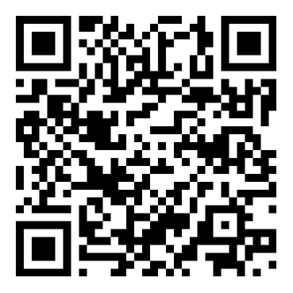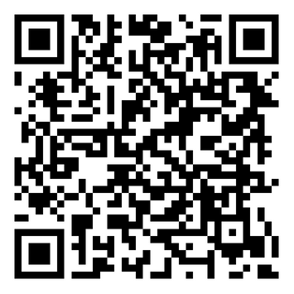

**Or**

**Call Greenwich Campus Security**

**Internal no: 8429  
External no: 020 8331 8429**

**Or**

**Contact a local first aider**

|  |  |  |
| --- | --- | --- |
| **Your local First Aiders are:** |  | **Your local Mental Health First Aiders are:** |
|  |  |  |
|  |  |  |

If the injury or illness is **life-threatening** or needs the skills / equipment of an **ambulance or paramedic team, please dial 999.**

Give the exact address where help is needed, including the building name and room number. **The postcode for Stockwell Street campus is SE10 9BD**

**Then inform Campus Security**,via SafeZone or on 8429 (or, 020 8331 8429)  
so they can help you and also direct the ambulance on arrival

**Defibrillators are kept at the** King William Reception / Dreadnought Reception / Stockwell Street Reception / Devonport House / Cooper Powerhouse Stair Foyer / Bounty House security guards office/ Hamilton House Reception / Halls of residence - Daniel Defoe Hall Reception/ Cutty Sark Hall Reception.

Report all accidents and near misses, injuries, sudden illnesses and first aider attendancesusing the University online accident / incident reporting system